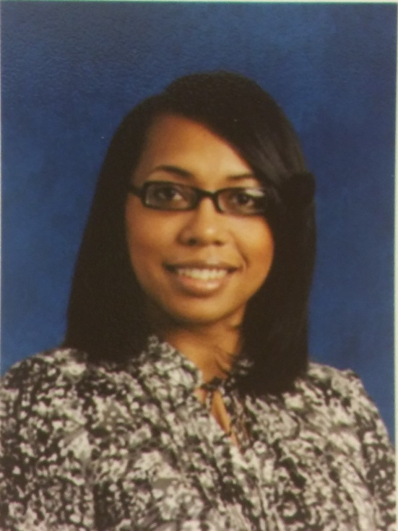

Greetings! It is my pleasure to serve as the new proud principal of River Oaks Middle School. I was born in Prince George’s County Maryland and have spent my life between there and Durham, North Carolina. I am a product of Durham Public Schools and graduated from North Carolina Central University with a Bachelor of Science in Chemistry, a Master of Administration in Executive Leadership from Gardner-Webb University and am currently seeking my Doctoral Degree in Educational Leadership from High Point University. I am the middle daughter of five, and have a wonderful daughter, Sydney.
I have served in many instructional roles including Assistant Principal and Principal in Prince George’s County Public Schools in Maryland, Durham Public Schools and Guilford County School for more than 23 years.
I am truly excited to have joined both the Wake County Public School and the River Oaks Middle School Families! I look forward to serving and leading ROMS with LOVE.

